DOCKER Advanced commands - Image and managing processes.

1. First configure EC2 ubuntu instance and docker on the same.
2. docker pull tomcat – to pull/clone the image from the official website.

1. docker images: view cloned images

1. docker rmi imageid : to delete docker images

1. docker pull Basappa.kadagoudar/alpine : for logging private image(before you need to login on the docker)

docker login : for logging to the docker

1. docker tag imageID tagname: used to tag the images:  
   A computer screen with numbers and letters

   AI-generated content may be incorrect.
2. docker push imageid: used to push image to repository
3. docker system prune : delete all containers/images wlll be removed except the running images, unused networks and volumes, stopped contaciner and cache

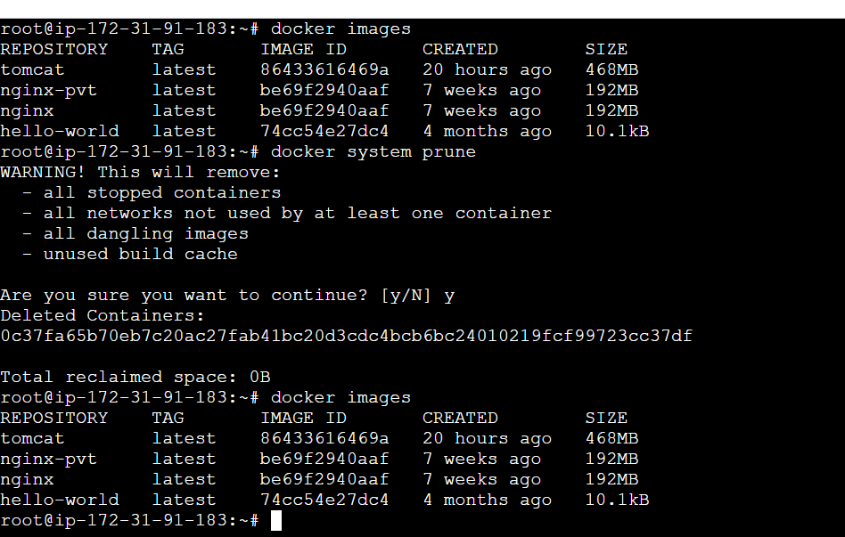

1. docker save -o tomcat.tar tomcat : to save the the container or backup of the container

